# CS-600-A Homework 4

Zijing Huang 10414952

**C-6.6 A *multimap* is data structure that allows for multiple values to be associated with the same key. It has a put(k, v) method, which inserts an item with key k and value v even if there is already an item with key k (but not the same key-value pair), and a FindAll(k) method, which returns all the values that have the key k. Describe a scheme that implements a multimap so that the put(k, v) method runs in O(1) expected time and the FindAll(k) method runs in O(1 + s) time, where s is the number of values with key k.**

We can use a hash function to create a mapping structure, such as hashmap. But hashmap can’t put multiple value to one key, so we can create a linked list data structure to connect all the value and the whole linked list as one value. It’s just like an adjacency list as following diagram:

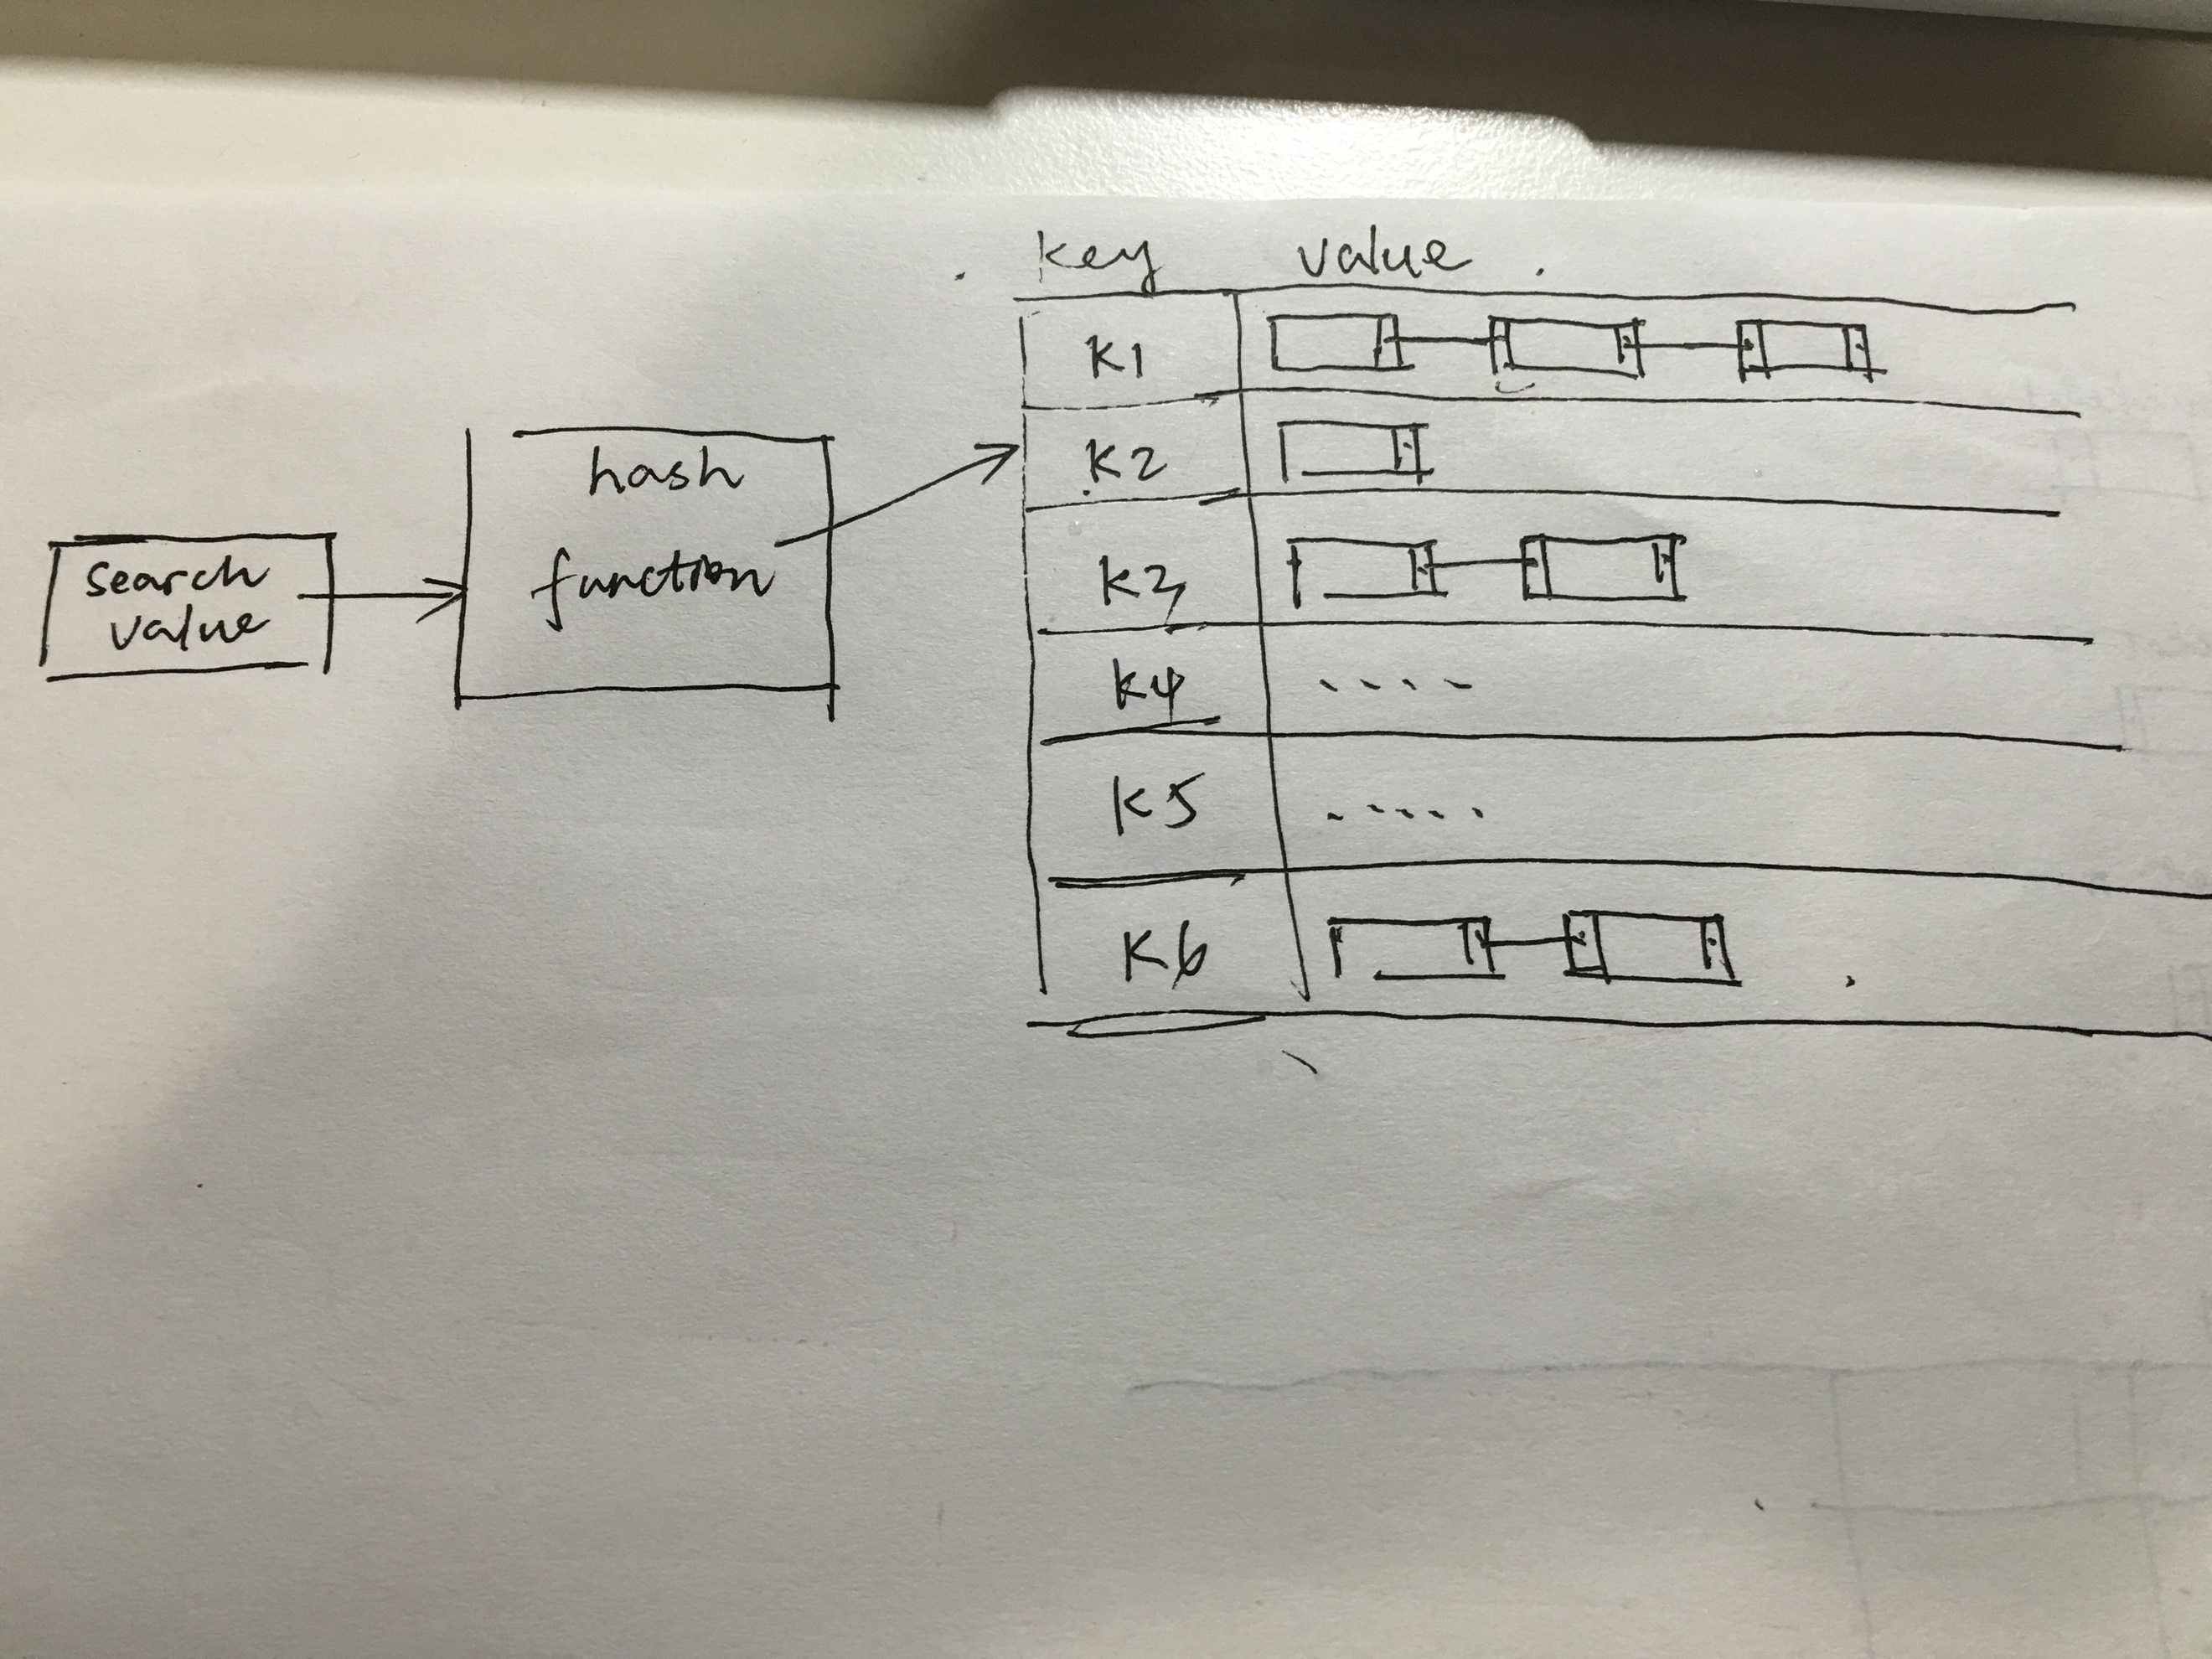

Because hash function cost O(1) time and insert into a linked list cost O(1) time as well, the put(k,v) method runs in O(1) time. And also finding all values runs in s time while we got the address of the header of the linked list. Therefore, the FindAll(k) method runs in O(1+s).

**A-6.4 Sports announcers are expected to keep talking during a broadcast of a sporting event even when there is nothing actually happening, such as during half-time. One common way to fill empty time is with sports trivia. Suppose, then, that you are going to be a sports announcer for the big game between the Bears and the Anteaters. To fill the empty time during half-time, you would like to say that this is the nth time that a game between the Bears and Anteaters has had a score of i-versus-j at half-time. The problem is that you don’t know the values of i and j yet, of course, because the game hasn’t happened yet, and, once half-time arrives you won’t have time to look through the entire list of Bear-Anteater half-time scores to count the number of times the pair (i, j) appears. Describe an efficient scheme for processing the list of Bear-Anteater half-time scores before the game so that you can quickly say, right at the start of half-time, how many times the pair (i, j) has occurred at similar moments in the past. Ideally, you would like the processing task to take time proportional to the number of previous games and the querying task to take constant time.**

We use a Hashmap implemented by cuckoo hashing to store the pair(i,j) and matching count. Because in the separate chaining and open addressing hashing schemes, the running time for doing a search is expected to be O(1), but it can be as bad as O(n) in the worst case. We use cuckoo hashing to reduce the searching time to O(1). The Hashmap data structure is as following diagram:

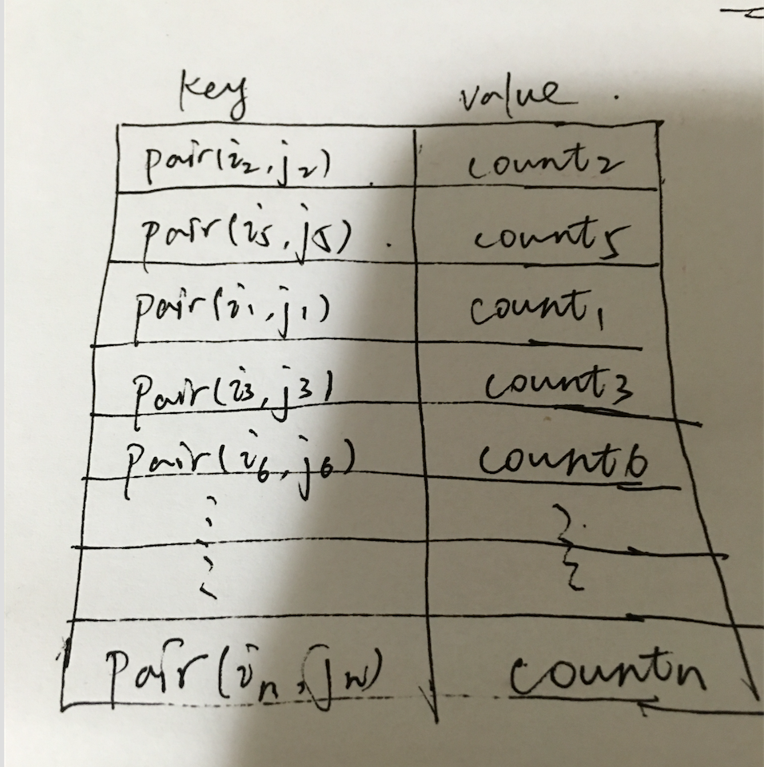

**A-6.5 Imagine that you are building an online plagiarism checker, which allows teachers in the land of Edutopia to submit papers written by their students and check if any of those students have copied whole sections from a set, D, of documents written in the Edutopian language that you have collected from the Internet. You have at your disposal a parser, P, that can take any document, d, and separate it into a sequence of its n words in their given order (with duplicates included) in O(n) time. You also have a perfect hash function, h, that maps any Edutopian word to an integer in the range from 1 to 1,000,000, with no collisions, in constant time. It is considered an act of plagiarism if any student uses a sequence of m words (in their given order) from a document in D, where m is a parameter set by parliament. Describe a system whereby you can read in an Edutopian document, d, of n words, and test if it contains an act of plagiarism. Your system should process the set of documents in D in expected time proportional to their total length, which is done just once. Then, your system should be able to process any given document, d, of n words, in expected O(n + m) time (not O(nm) time!) to detect a possible act of plagiarism.**

First of all, for each m words in D, we can use a polynomial hash function to produce set K of hash value. And also, for every constant m values, we use polynomial hash function to generate the hash value set K’ as well. We traverse K’ and can find an act of plagiarism by finding an element both in K and K’. So it takes O(n + m) time. I draw a diagram about the algorithm and it is as following:

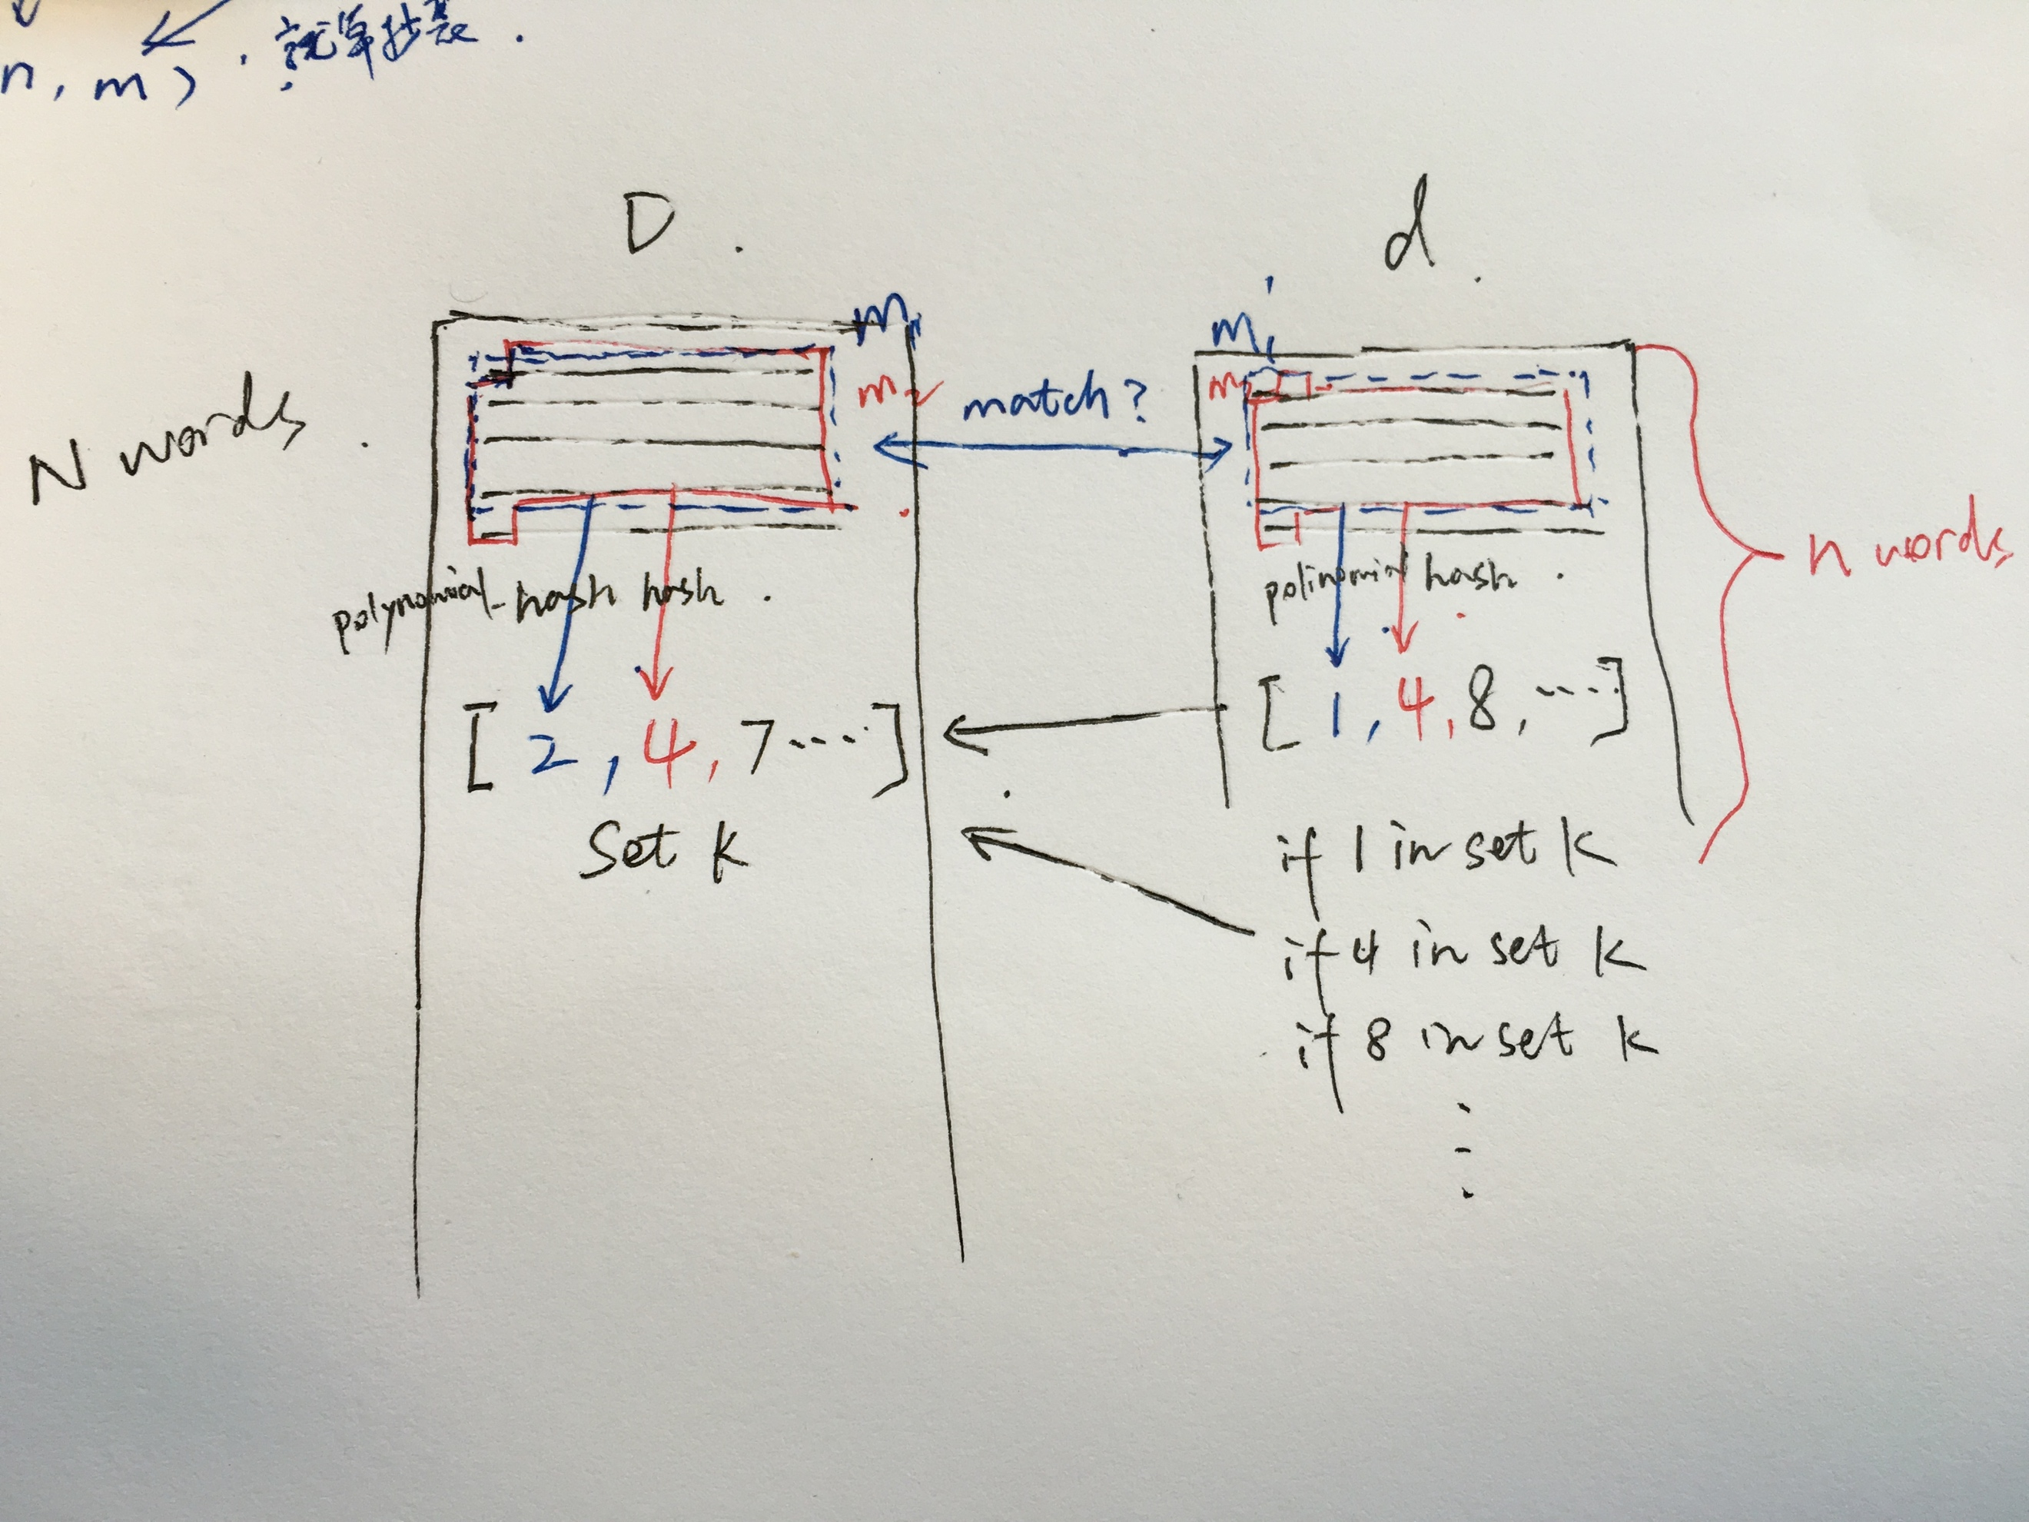

**R-7.5 One additional feature of the list-based implementation of a union-find structure is that it allows for the contents of any set in a partition to be listed in time proportional to the size of the set. Describe how this can be done.**

Because each set is stored in a sequence represented with a linked-list, we can traverse each set starting from the header pointer as following:

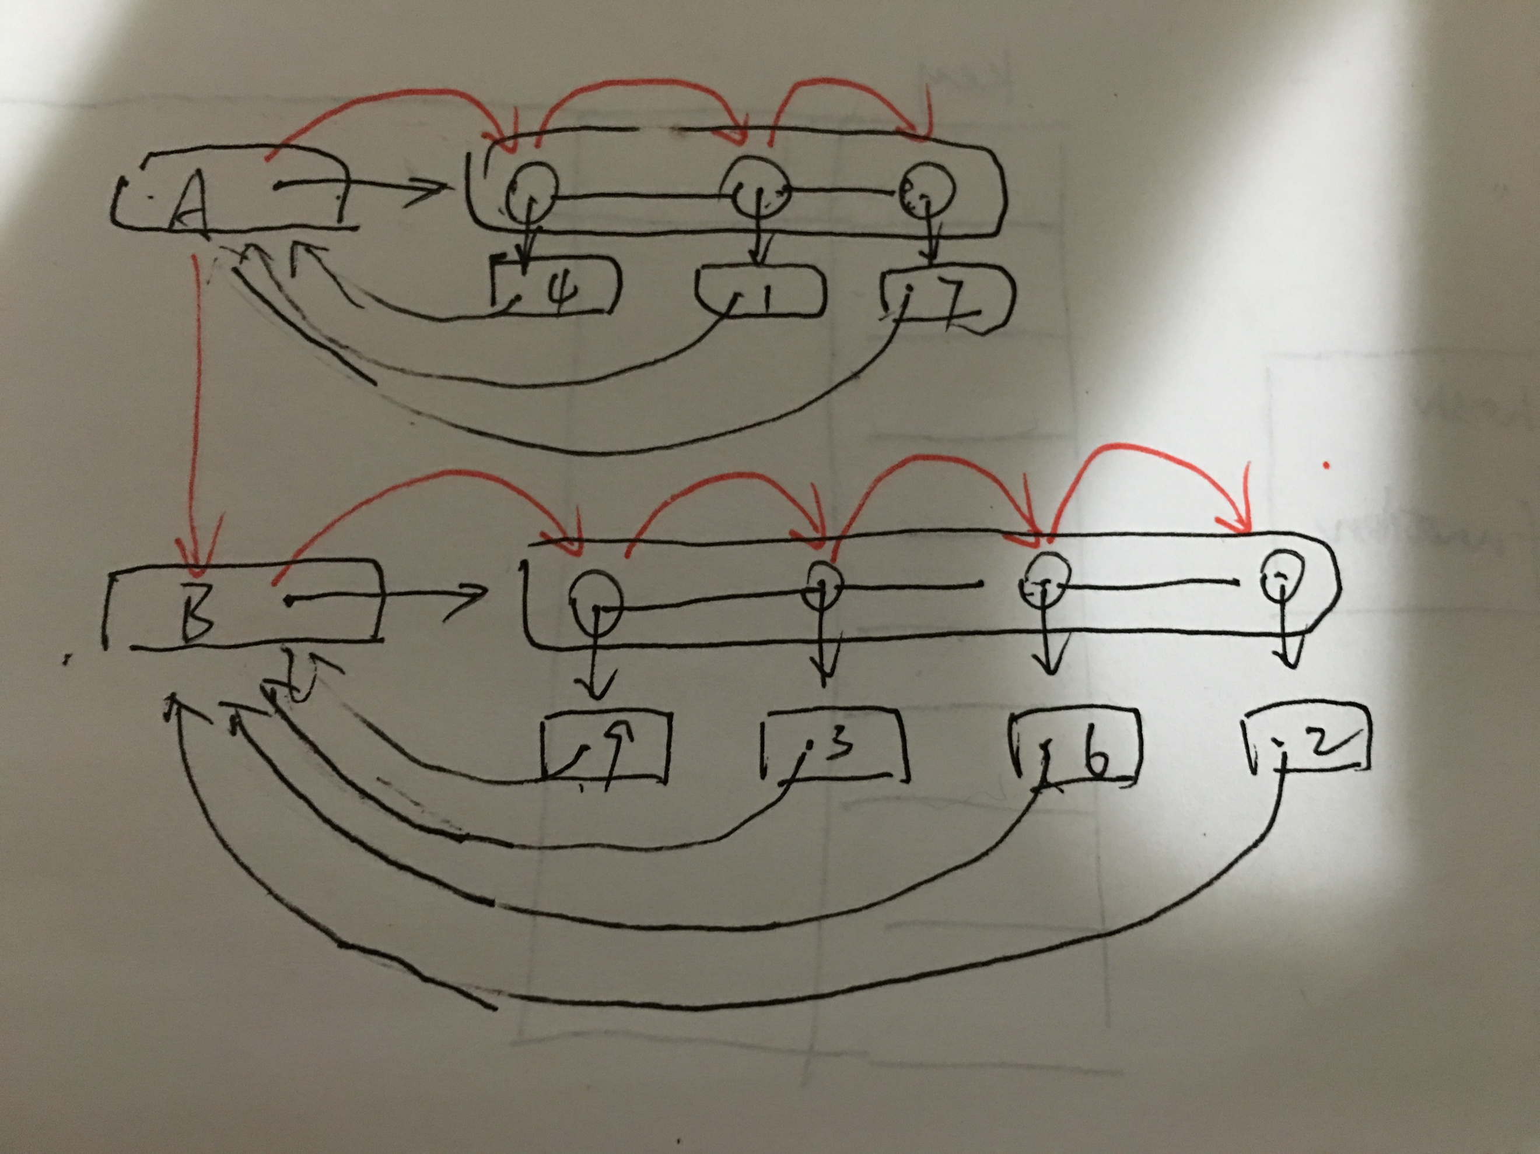

**C-7.2 Consider a method, remove(e), which removes e from whichever list it belongs to, in a list-based implementation of a union-find structure. Describe how to modify the list-based implementation so that this method runs in time O(1).**

In the original method case, in order to remove the element, what we need to do is:

Suppose we have found the element to be removed.

1. To find the previous node of the target node. (takes O(n) in the worst case)
2. Let the previous node points to the node behind the target node.(O(1))

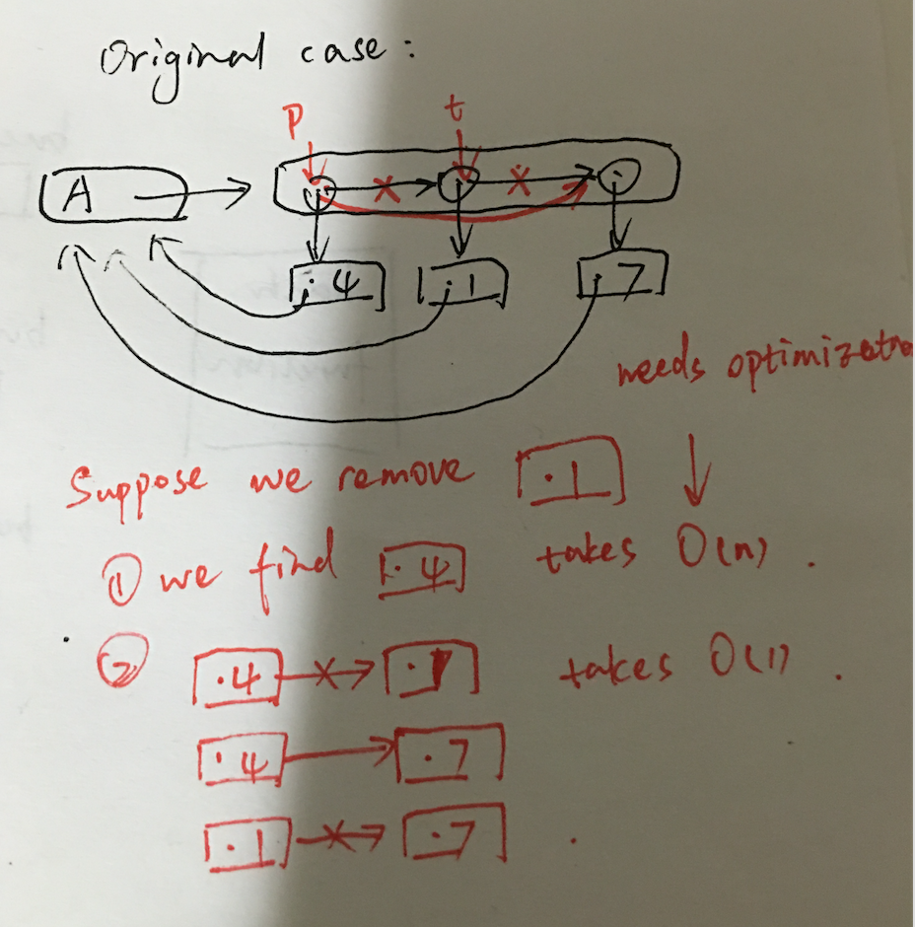

Because we spend O(n) on finding previous node of target node, we can optimize by using doubly linked-list, which we only spend O(1) for finding previous node base on knowing the position of target node.

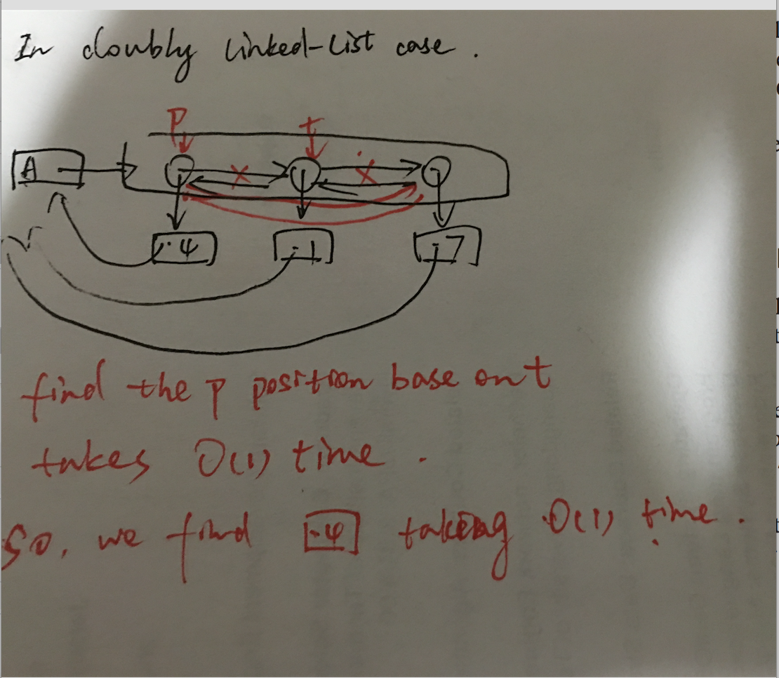

**C-7.4 Let A be a collection of objects. Describe an efficient method for converting A into a set. That is, remove all duplicates from A. What is the running time of this method?**

The brute force solution: O(n2)

Comparing each element in the collection with others, remove the duplicates. It takes O(n2) on this solution.

Sort method: O(nlogn)

Firstly, sort all the elements in the collection base on quick sort which takes O(nlogn). (If we know the range of elements, we can use bucket sort, which only takes O(n)). And then we traverse the sorted list and remove the duplicates.

Hash method: O(n)

We can design a hashing function which put the unique values to different buckets and the duplicate values to the same buckets. And then We can traverse the buckets, get the values from the buckets and add to a set. It takes O(n) time.

**A-7.2 One of the tasks for an operating system is the job of scheduling computations to be performed by the processor(s) that are part of that system. A subtask that comes up in some processor scheduling problems is to solve a sequence σ of O(n) priority queue operations, where each operation in σ is either an insert(i) or removeMin(), such that i is a distinct integer in the range from 1 to n. This problem is known as the *offline-min problem*, since the entire sequence, σ, is given in advance. Interestingly, the offline nature of this problem gives us a faster way of answering the operations in σ than using a heap. Namely, if k is the smallest integer inserted somewhere in σ, then we know the very next removeMin() in σ will return k. Likewise, after we have matched up k and this removeMin(), and deleted both from σ, then we can repeat this argument on the operations that remain. Use this observation to design an algorithm for answering all the operations in σ in O(nα(n)) time, and thereby solve the offline-min problem.**

We can use a disjoint-set forest (a tree-base union find) data structure. This question requires us to input a sequence σ, the number of insertion n and the number of extraction m. What we need to output is the array of extraction.

So firstly, we denote any elements between the two continuous extractions as set Kj. And then for the element i from 1 to n, if i is in Kj and j isn’t the last range, we give this value to extraction[j]. And then we union j and its next range. And we do the same steps recursively until we fill out the extraction array.

For example, we have a sequence [4,8,E,3,E,9,2,6,E,E,E,1,7,E,5] as following diagram:

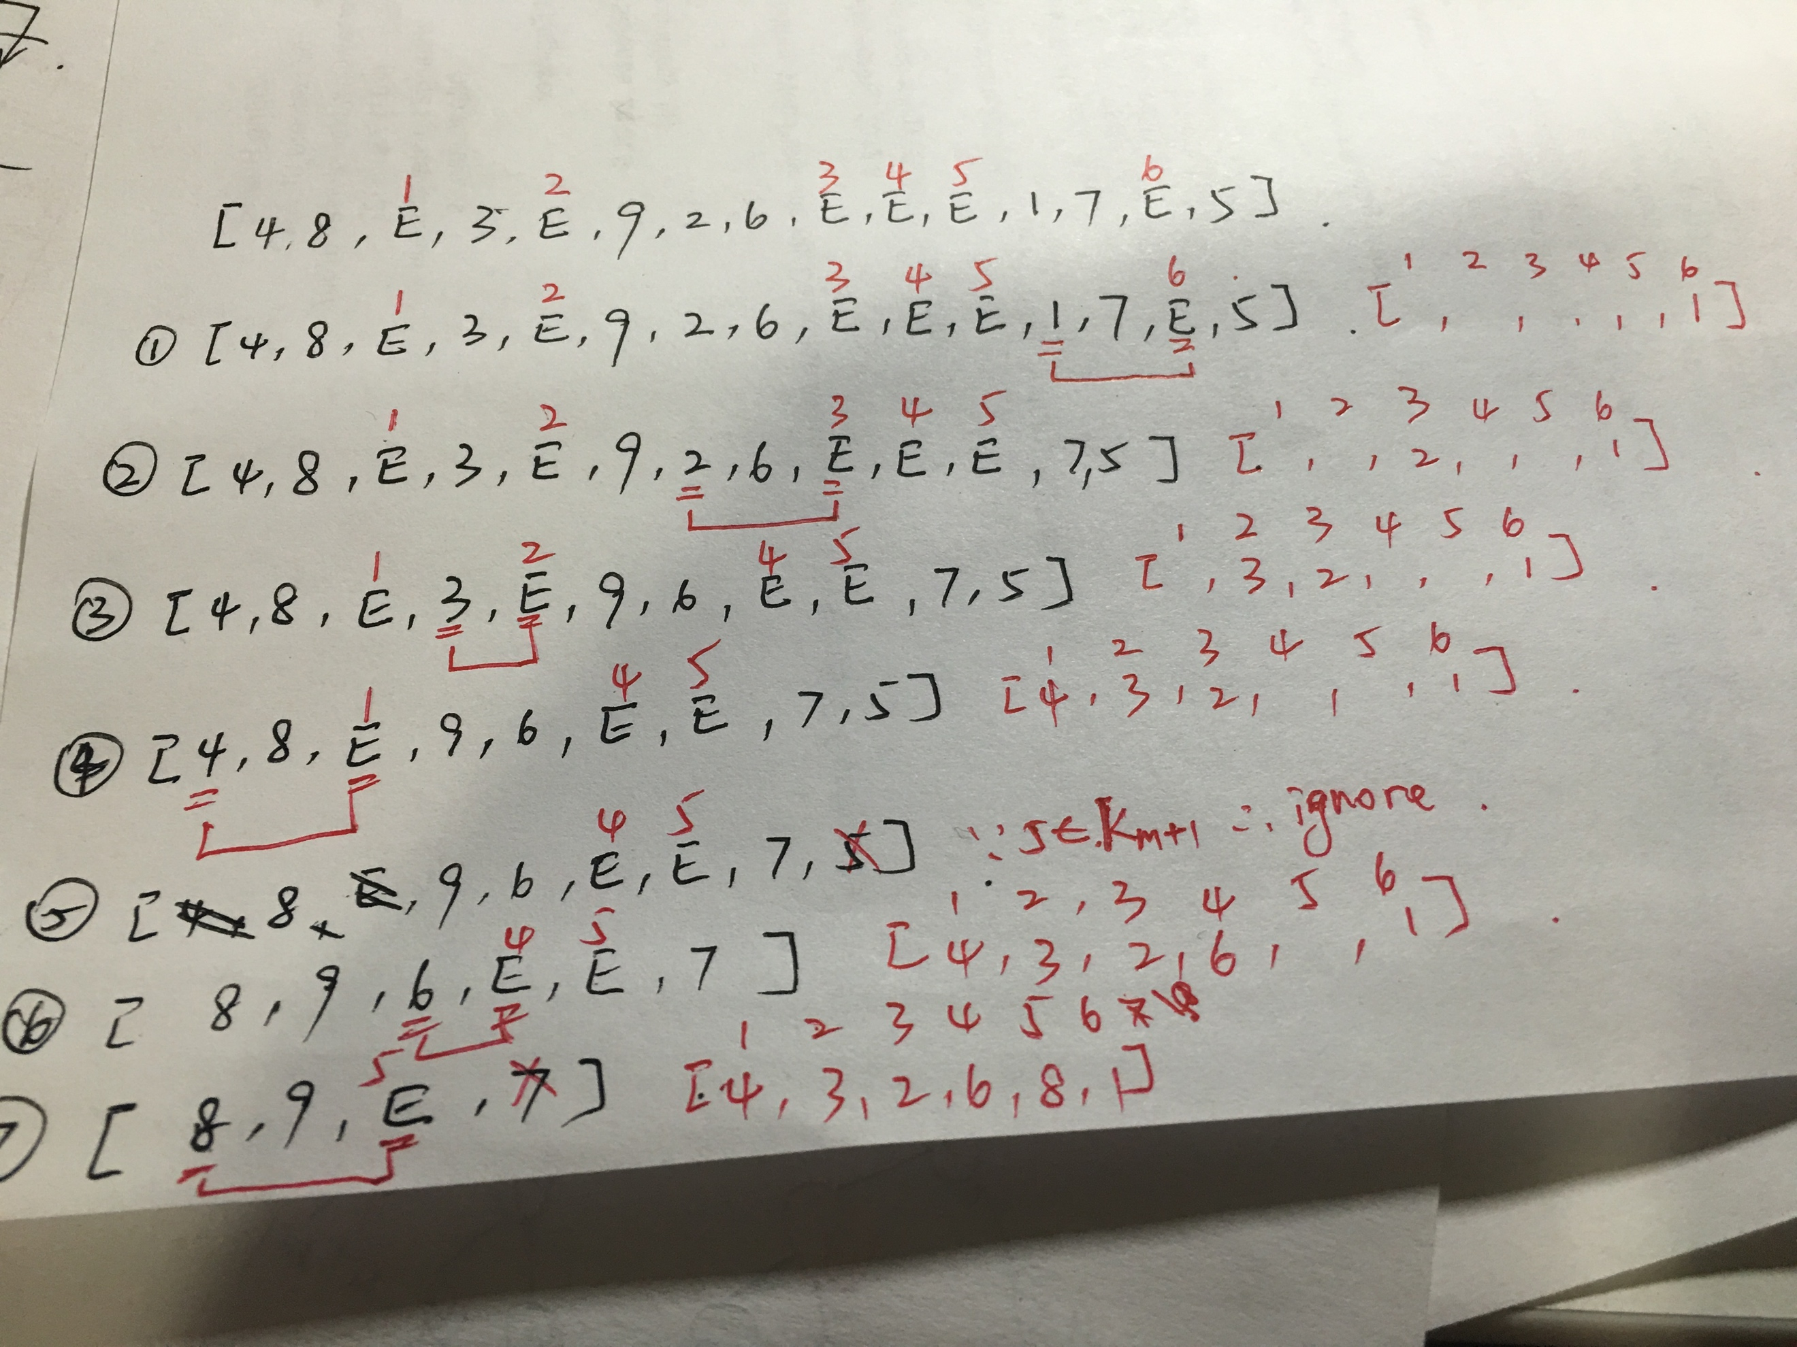

The result is [4,3,2,6,8,1].

Suming over all possible ranks, the total number of cyber-dollars charged to all nodes is at most

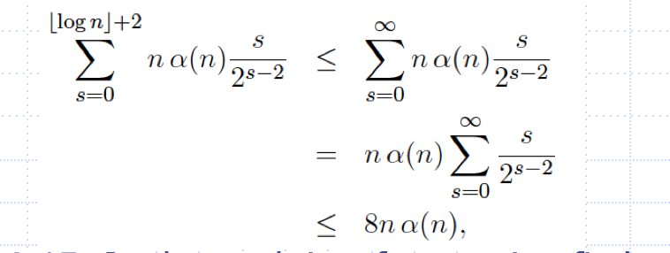

using Theorem A.15. So the total time for m union-find operations, starting with n singleton sets is O((n+m)α(n)).

Reference: PPT 10-20 and page 517 of *Introduction to Algorithms.*